

There comes a time in every recently inaugurated Canberran’s life when they actually feel a strange desire to explore what the weird and wacky city we live in has to offer. The Billitin encourages, nay exhorts you to go with this feeling, go with the flow and see what this city has to offer, whether it be shakes which art freaky, or art which happens to not be apart, get out there and see this city!

*Doing it for Bill since 2014*

THE BRUCE BILLITIN

**ISSUE 07: Monday 21th March- Sunday 27th March**

*Doing it for Bill since 2014*



SCHIMDT HAPPENS- Canberra and ANU

INDIA-AUSTRALIA TIES: Glimpses through a diplomat’s diary

On Tuesday the 22nd March 2016 at 3pm in Theatre 1 of the Hedley Bull Building listen to the Indian High Commissioner H.E. Navdeep Suri provide a unique insight into advancing ties between the two countries.

HOW CAN YOU CHANGE THE WORLD

On Wednesday the 23rd of March at 6pm in the Australian Centre on China in the World come listen to three leading young social entrepreneurs participate in a panel discussion followed by a Q&A on how you too can change the world.

TERTIARY TO WORK FAIR

On Wednesday March 23rd from 11am 🡪 3pm in the National Convention Centre Canberra’s largest careers fair will take place, with the event attended by more than 50 of Australia’s largest employers. A free shuttle bus will operate from Union Court at North Road to and from the venue throughout the day. You must register beforehand, and the link for doing so as well as more info can be found at www.anusa.com.au/event/tertiary-to-work-fair/

Easter is a beautiful time of year, when you can stuff your face full of chocolate and be traumatized by pictures such as these

BRUCE HALL: Whats on in our Historic Hall

After our recent triumph in Debating and our podium finish in Road Relay, Bruce Hall is going forward in leaps and strides on both the sports and arts shields. Here’s whats on this week:

Arts

Interhall talent night is this Tuesday the 22nd of March at 7pm in the Arts Centre in Union Court. Come down and support our very own young Frank Sinatra Tavish as he croons his way into the judges hearts, before hearing Julia’s fiery poetry incite a revolution in the hearts and minds of all those listening.

Sports

Both the Guys and Girls basketball teams will be playing important games later this week, stay posted for their game times.

Word has it that there may also be a certain eggy themed hunt later this week, so keep your ears peeled for the tell-tale hop-skip and jump of the Easter Bunny at Bruce…..

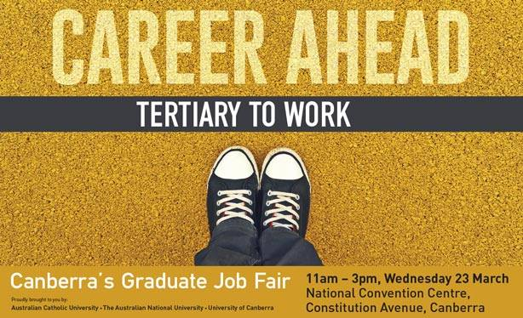

*FlubberDobberDobberDobber –* Bill/Ben the Flowerpot Men



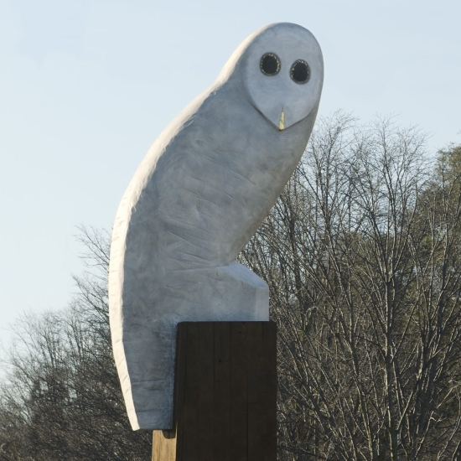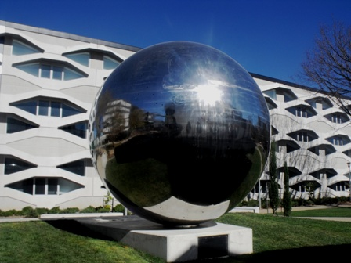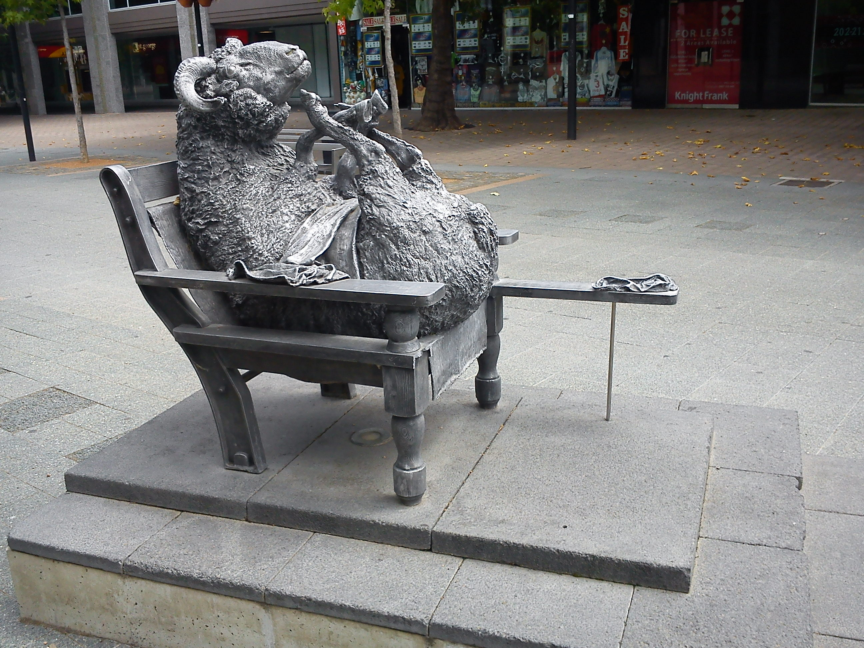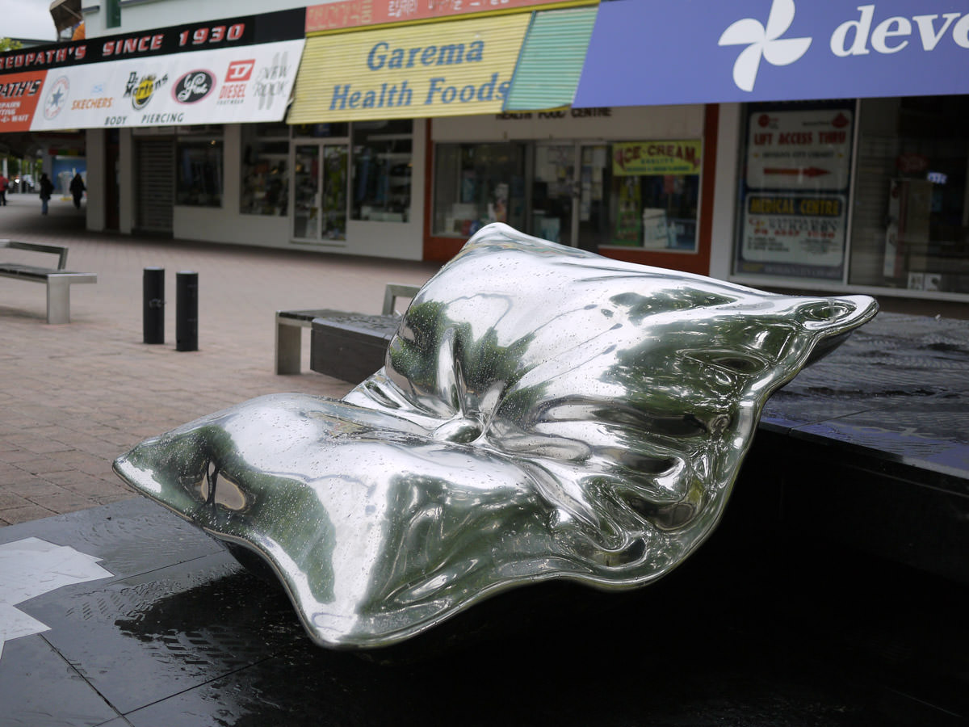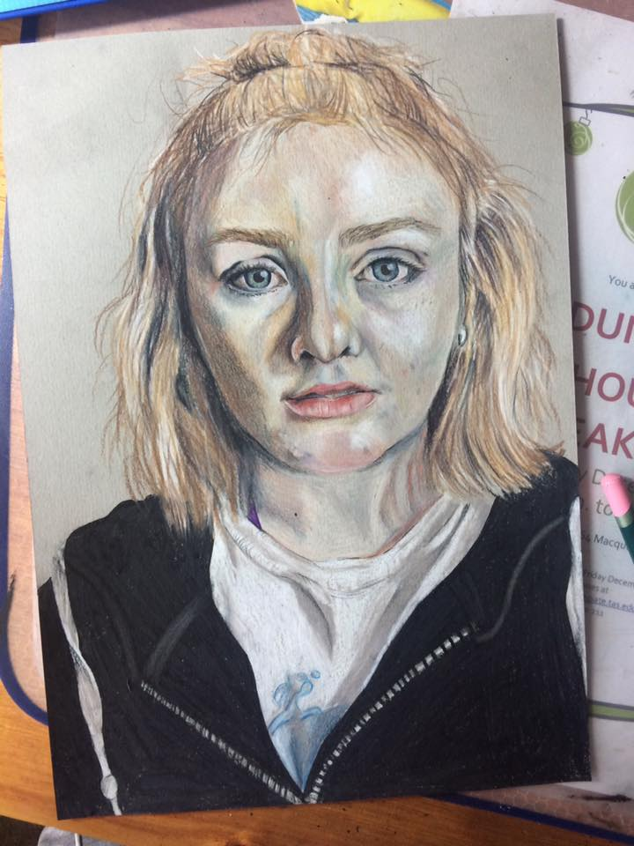

THE MEANING BEHIND CANBERRA’S PUBLIC ART  
- With Lucy Cripps

**When you waltz through the streets of Canberra, serenading all those  
around you with your beneficient gaze, evaluating the art that is within  
and the art that is apart, you may feel curious about the magnificent  
public artworks which surround us here in this most bohemian of cities.**

**If you are caught in Garema place trying to suckle from the pillow, or   
are even paralyzed by the sheep’s seductive glare, then this guide is for   
you.**

The “Owl”

This owl, which some clearly deranged souls compare to a phallic object, is a totem at the end of Belconnen way, symbolizing the power and grace that is the native Canberran on the dancefloor of Mooseheads. It was made by Bruce Armstrong, and stands at attention for all to see.

The Pillow

Not as most people seem to believe, a silver bag for the consumption of wine of a slightly

lesser value (as is done in social south on occasion), rather this sculpture is one of a pillow.

It is supposedly the full extent of the ACT government’s support for the homeless.

The Sheep

The sheep are the epitome of the Canberra man. Slow, fluffy, and careful not to disobey those who feed and clothe them, the sheep were a gift from the New Zealand embassy, hence it’s seductive stare. Art comes from the heart, and it seems the makers of this one really held the object close to theirs.

The Sparkly ball with Holes

It is said that if you look into the holes of this ball when the sun is up, you can see the whole

galaxy laid out before you. This is typical uninspired science talk, as this ball represents an

artists ceremonial middle finger (the said artist wanted to do a deconstructed middle finger,

a.k.a. a knuckle) to the establishment of science and all the constraints it imposes,

like ‘gravity’ and ‘STD’s’.

Canberra is home to many more unique and articulated masterpieces, scattered haphazardly through the wastelands of concrete in which we live. Look out for these expressions of our inner thoughts and desires, and one day you too may become more in tune with the artistic side which forms the centre of all our true beings.

TRIVIA

1. The titular characters of the comic’s Asterix and Obelix were 6. In which country was Einstein born? from which barbarian tribe? 7. How many years did it take for a successful proof to be

2. What is the only doubly land locked country in Europe? Developed for Fermat’s Last Theorem?

3. What was the name of the group of Serbian assassins who killed 8. Who wrote the seminal horror novel Dracula?  
 Archduke Franz Ferdinand? 9. What is the largest city in the world by population?

4. What Australian Prime Minister was Bruce Hall named after? 10. What decade were the first paper money bills created?

5. What team has won the English Premier League the most?



1. The Gauls, 2. Liechtenstein, 3. The Black Hand, 4. Stanley Melbourne Bruce, 5. Manchester United, 6. Germany, 7. 358 years, 8. Bram Stoker, 9. Tokyo, 10. 1860’s

TRIVIA

1. The titular characters of the comic’s Asterix and Obelix were

From which barbarian tribe?

2. What is the only doubly land locked country in Europe?

3. What was the name of the group of serbain assassins who killed  
 Archduke Franz Ferdinand?